You are cordially invited to a tea ceremony for peace
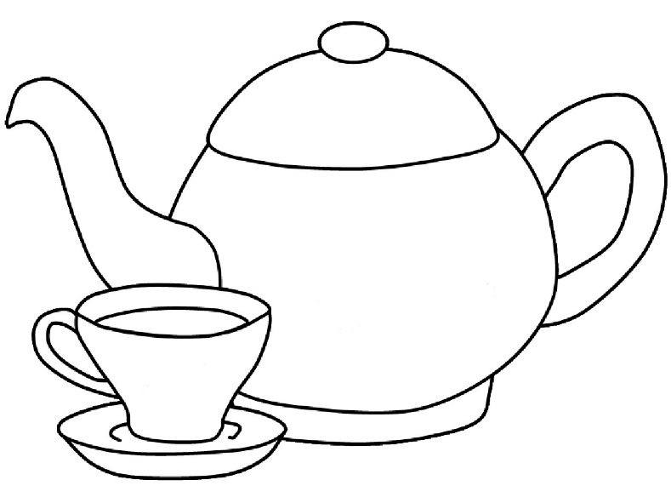

Thank you for being a piece of the peace!

Wherever you are on , join us for some quiet time to sip tea and reflect upon some words of peace. Attached is a bag of Equal Exchange Fair Trade tea. We hope this tea quiets your mind, soothes your spirit, and brings you perspective as we work toward peace in our families, communities, and the world.

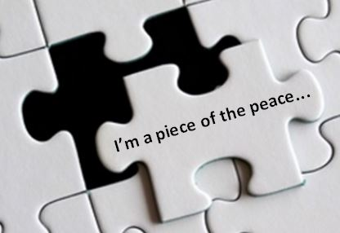

Some words of peace . . .

Seek peace, and pursue it. ~ Psalm 34:13
The powerful have always been willing to baptize the status quo and name it “peace,” and the impotent are regularly accused of being troublemakers when all they seek is justice. ~ Sam Keen
Let the peace of Christ, rule in your hearts. ~ Colossians 3:15
Lord, make me an instrument of Thy peace. Where there is hatred, let me sow love; where there is injury, pardon; where there is doubt, faith; where there is despair, hope; where there is sadness, joy; where there is darkness, light. ~ St. Francis of Assisi
Peace cannot be kept by force; it can only be achieved by understanding. Darkness cannot drive out darkness; only light can do that. Hate cannot drive out hate; only love can do that.
~ Martin Luther King, Jr.
When I see Spirit in everything, Peace is at hand. ~Jonathan Huie
I no longer pray for peace. I pray for miracles. ~ Ann Weems
Have a cup of tea, pray for peace (and miracles!), then actively work to make it so.

