Heal the Earth…Our Home!

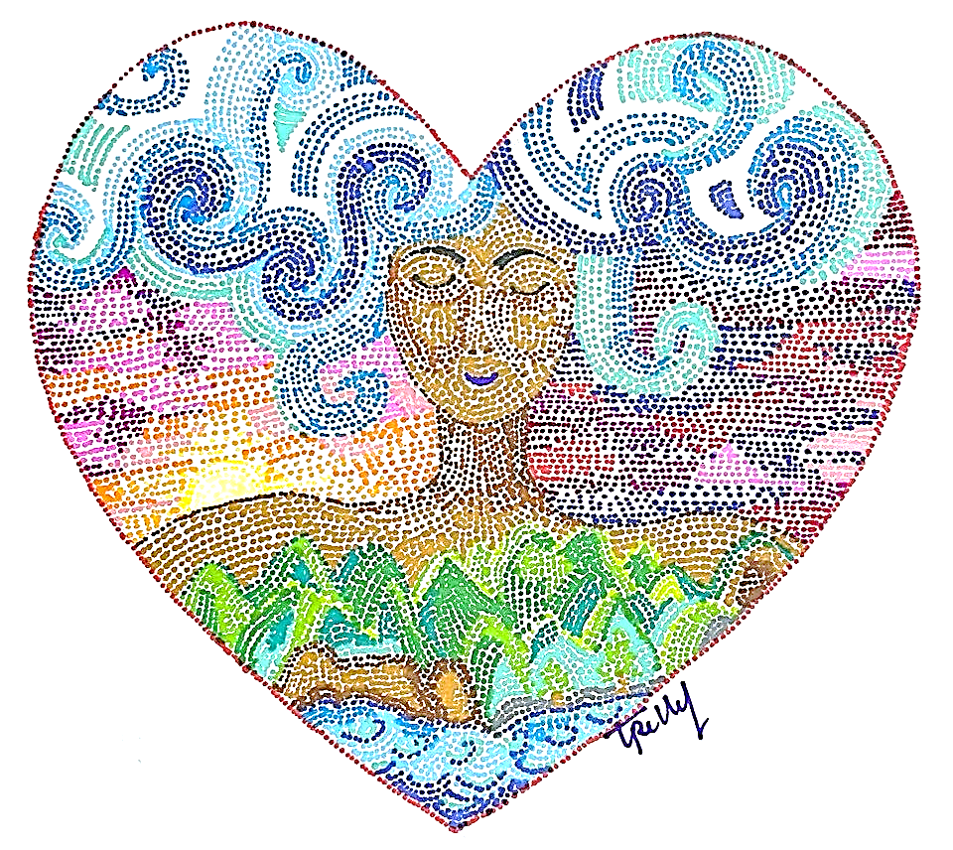
Artwork: Trelly Marigza, the Philippines

2022 FLC IN-GATHERING LITURGY

Heal the Earth…Our Home!

The Fellowship of the Least Coin’s In-Gathering Service is an offering from the International Committee for the Fellowship of the Least Coin (ICFLC) as a suggested guide. There is a space for local women’s groups and churches to choose hymns and different ways of connecting (ex. dramatization, message, presentation, small group discussions). As well, this service includes room for different leaders and voices to encourage greater participation.

The In-Gathering Liturgy is published and distributed every July of the year, just in time for the traditional month of holding the FLC In-Gathering Worship in every September of the year. And, for our regional ecumenical partners, denominational partners, women’s groups, and local congregations to hold In-Gathering Services throughout the year to suit the needs of different groups.

The ICFLC would greatly appreciate your feedback on the In-Gathering Liturgy as well as personal anecdotes, stories, and photos of your worship service. As well, during the pandemic, we encourage all groups to follow the latest health and safety guidelines in their communities to ensure the safety of all who gather. Please send any feedback to: icflcph@gmail.com

May you have a meaningful worship!

PRELUDE

To signal the coming together of the community some instruments may be used like chimes, bells, rainmakers, cymbals, gongs, or any instrumental music. (If possible, the activity can be done outdoors like in a garden, beach, campsite, or forest to feel the nature.)

While the musical instruments are being played, selected participants will dance bringing the following to the altar or center of worship (not in order) water, fire, soil, vegetables, fruits, rice, plants, flowers, wooden/bamboo cross, or anything else that may symbolize God’s creation.

WELCOME AND GREETINGS

CALL TO WORSHIP

Liturgist: And God said, “Let the water under the sky be gathered into one place and let dry ground appear.” And it was so. God called the dry ground “land,” and gathered waters God called “seas.” And God saw that it was good. Then God said, “Let the land produce vegetation: seed-bearing plants and trees on the land that bear fruit with seed in it, according to their various kinds.” And it was so. The land produces vegetation: plants bearing seeds according to their kinds. And God saw that it was good!

People: Thank you God, our creator of land and ocean which are the sources of our food and livelihood. To the soil that yields vegetables, fruits, trees, flowers, plants, and the ocean which is the source of marine resources. All that we see around us, big or small, living or non-living, every shape, every color, are all your creations.

Liturgist: Then God said, “Let us make humankind in our image, according to our likeness, and let them have dominion over the fish of the sea, over the birds of the air, and over the cattle, and over all the wild animals of the earth and over every creeping thing that creeps upon the earth.” So God created humankind, in his own image, in the image of God he created them; male and female he created them.

People: We praise and thank you God, our Creator of humanity and of the Earth!

HYMN OF PRAISE

Liturgist: Thank you God, our creator of humanity. We are the ones you have entrusted to be in-charge of all that you have created in the whole world. To lead and share equally the blessings that come from you. But we have become greedy, selfish and thinking only about ourselves. We have completely forgotten our responsibility as stewards of your creation. We have let you down, O God!

MOMENTS OF SILENT CONTEMPLATION ON THE DESTRUCTION OF THE EARTH, OUR HOME.

Some suggestions:
- Images or music can be used to depict the destruction of our Earth and the effects of climate change to both people and Earth.

- Sharing of lamentations from participants as observed in their communities, in the form of a lament.

Liturgist: We have become greedy, selfish and thinking only about ourselves. We have completely forgotten our responsibility as loving stewards of your creation. We have also forgotten that we are part of nature that you created.
Nature can survive without us human beings, but we cannot, without nature. We human beings, have let you down, O God! We ask for your grace and forgiveness…

MOMENTS OF SILENCE

People: And now, we say, “Let all the inhabitants of the earth tremble!” We have heard the wailing and witnessed the ravaging of nature. We have seen and heard the weeping of the exploited and oppressed in the name of development. We are ready, and we are now crying out for justice! Strengthen us, O God we pray, to commit to work with each other to restore justice to the Earth, our home.

PRAYER

Let us pray for an end to the
Waste and desecration of God's creation
For access to the fruits of creation
To be shared equally among all people
And for communities and nations to find sustenance
In the fruits of the earth and the water God has given us.

Almighty God, you created the world and gave it
Into our care so that, in obedience to you,
We might serve all people:
Inspire us to use the riches of creation with wisdom,
and to ensure that their blessings are shared by all;
That, trusting in your bounty, all people may be
Empowered to seek freedom from poverty, famine, and oppression. Amen.
(Prayer from jesuitresource.org)

SCRIPTURE READINGS: Psalms 96: 11-13; Psalms 135:5-6;
Romans 8:19-23

HOMILY, OR SHARED REFLECTION ON YOUR FLC STORY IN CARING FOR OUR HOME, THE EARTH

Suggested points to consider:

- What can you personally (or your group) contribute to help heal our ailing Earth? Specifically, what can you do to care for the Earth and its inhabitants in your own community and context?
- What are the signs of hope you see around you, that will help restore our beloved Earth and all of creation therein to total well-being?
- How can you (or your group) help strengthen the Fellowship of the Least Coin (FLC) as an ecumenical movement in its commitment for justice and peace (not only for humanity) but also for the Earth, our home?
- Commitment-making: you or group may commit to do something concrete like: Attend or organize an Earth Day event, tree planting, join a cleanup drive, go on a nature walk-meditation, plant a garden, etc. Write your commitment on a card and offer this together with your FLC Offerings later.
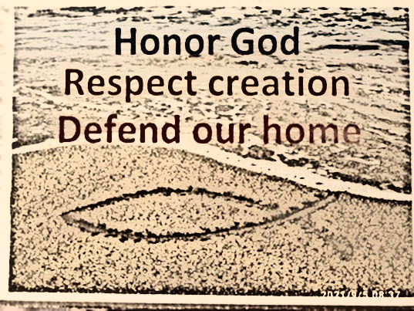
HYMN

OUR FLC STORY (Optional, see Appendix 1)

OFFERING OF FLC LEAST COIN OFFERINGS

BLESSING OF FLC OFFERINGS AND COMMITMENTS Cards,
AND PRAYER FOR THE FLC MOVEMENT

DOXOLOGY
Praise God, from whom all blessings flow.
Praise God, all creatures high and low.
Praise God, in Jesus fully known:
Creator, Word and Spirit One. Amen.

CALL TO COMMITMENT

People:
Let us renew our sense of the earth and all life.
We join with the earth and each other
To bring new life to the land
To restore the waters
To refresh the air.

Women: We join with the earth and each other
To renew the forests
To care for the plants
To protect the creatures.

Men: We join with the earth and each other
To celebrate the seas
To rejoice in the sunlight
To sing the song of the stars.

Youth and Children: We join with the earth and each other
To create the human community
To promote justice and peace
And the integrity of all creation.

People: We join with the earth and each other
To remember our children
And the generations to come
That they, too, may inherit the earth
We join with all creation as one loving mystery, for the healing of the earth and the renewal of all life.

(Adapted from United Nations Environmental Program (UNEP) Only One Earth)

CLOSING HYMN Song of Healing
(To the tune of Morning Has Broken)

Healing is flowing, deep in the waters
Flowing from Eden, flowing from old
All through creations, God sends forth waters
Ocean of healing, all for the world.

Healing is rising, fresh with the morning
Healing is rising, bursting with grace
Come, our rich healing, deep in creation
Heal earth’s deep wounds and rise in this place.

Healing is offered, leaves from the life tree
Healing is offered nations at war
Come, wounded healer, torn by the violence
Rise from the grave, bring peace to our shore.

Healing is given, flows from forgiveness
Healing is given, flows from our faith
Christ, give us heart to love your deep healing
Living forgiveness, even in death.

Healing is rising, free in Christ’s body
Healing is flowing, free with Christ’s blood
May this deep healing pulse through our bodies
Heal the world’s wounds still bleeding and red.

CLOSING PRAYER

THE COMMUNITY BLESSING

May joy and hope live in our hearts with the Promises of God in the fullness of life!
May God grant us the wisdom to take care of the earth.
May we give justice to those who have been abused and exploited because of our greediness and selflessness.
May we all live in peace and harmony with God's creations.
May God touch each one of us, so that we may heal the wounds of our world, our home.
May the blessings of God, the Creator, Liberator, and Sustainer of life be amongst us now and always, Amen!

APPENDIX
Our FLC Story (Creatively read or dramatized)

Alternative 1 (Longer Version):
Leader 2: The Fellowship of the Least Coin (FLC) was envisioned by Shanti Solomon, a Christian woman from India, in 1956. Shanti was part of an international mission team led by Presbyterian women from the United States. The team travelled throughout Asia to meet with and listen to women who had been touched by injustice during the Second World War. The team heard stories of violence and trauma, deep pain and distrust.
Leader 3: When Shanti and the team went to Japan, three Japanese women met them at the airport. They brought garlands for Shanti and others on the team, but they brought none for the Americans. They said, “We have had enough of General MacArthur… we do not welcome the American women on the team.” On that visit, Shanti saw destruction all over Japan, especially in Hiroshima, where, in 1945, the United States military dropped an atomic bomb that instantly killed 80,000 people and later killed tens of thousands of people due to radiation exposure.
Leader 4: When Shanti and the team went to the Philippines, they met with Filipinas who were selling their jewelry in order to rebuild their church. It had been reduced to rubble during the Japanese occupation. When Shanti asked the women if they would receive a mission team from Japan to have conversations about reconciliation they said, “Not during our lifetime.”
Leader 5: When the team went to South Korea, Shanti stayed behind in the Philippines since her visa application was denied. At that time, India and South Korea had tense diplomatic ties. After the Korean War, Indian Prime Minister Jawaharlal Nehru accepted the United Nation’s request to be the neutral world leader to settle the boundary between North and South Korea. Prime Minister Nehru settled the boundary at the 38th parallel even though most Koreans did not want their country to be divided at all. So, as an Indian citizen, Shanti was not welcome in South Korea.
Leader 2: After hearing these stories of hurt and resentment and experiencing divisions and borders herself, Shanti prayed for peace, justice, and reconciliation between countries and peoples. She believed that if individual Christian women could pray about these issues, they could create ripples of peace, justice, and reconciliation that would flow to people and places all around the world.

Leader 3: Shanti and the team pledged to pray whenever they were in conflict with another person. They committed to praying for the person that hurt them and they committed to praying for themselves – for strength and grace to seek understanding and offer forgiveness. As well, they committed to praying for peace, justice, and reconciliation around the world.
Leader 4: As a token of each prayer, they agreed to set aside the least coin in their currency. Only the least coin was offered so that women of all socioeconomic status could be generous and participate in this peace-making.
Leader 5: Today, the FLC is a global ecumenical movement of prayer for peace, justice, and reconciliation with prayers and least coins flowing to projects that support gender equality and human dignity.

Alternative 2 (Shorter Version):
Leader 2: The Fellowship of the Least Coin (FLC) is a global ecumenical prayer movement for peace, justice, and reconciliation. Through this movement, women around the world strive to be in solidarity with each other and are reminded to pray and work for peace.

Leader 3: The idea for the FLC emerged as a vision from God to Shanti Solomon of India. Shanti was part of the Pacific Mission Team, a group of seven women from different countries that traveled throughout Asia in 1956. The mission was organized by Dr. Margaret Shannon on behalf of the women of the Presbyterian Church of the United States of America (PCUSA). On this mission, Shanti heard stories from Asian women who had experienced abuse and trauma during the Second World War. Due to unfavourable diplomatic relations between India and South Korea at the time, Shanti was refused a visa to South Korea. So, she stayed in the Philippines and prayed about her experiences and the stories she had heard.

Leader 4: When the team met her in the Philippines, Shanti shared her vision of Christian women praying for peace to transcend every national boundary and human-made division. Shanti wanted all Christian women to pray for peace, justice, and reconciliation in their own lives and throughout the world and to set aside a coin as a token for each prayer. She proposed that all women give the “least coin” of their currency so that women of all socioeconomic status could be given opportunities to be generous and participate in this peacemaking.

Leader 5: She challenged the Christian women of Asia and the women from PCUSA to combine their efforts and resources to launch this project of justice, peace, and reconciliation. The team accepted Shanti’s challenge and the FLC was born.

RECOMMENDED ALTERNATIVE PRAYER/MEDITATION
For Mother Earth*
* By Reuel Norman O. Marigza (Divinity School, Silliman University, Dumaguete City, Philippines). Written as Closing Reflection for ATESEA/SEAGST Workshop on the theme: “Preserving Mother Earth: A Theological Concern,” STM, Malaysia

From dust we came
to dust return
we are children of the ground
and people of the earth

Sower of the seed,
Shaper of the dust,
Moulder of clay,
Giver of breath,
You made us rise from the ground
there must be a reason for
creating us so
to be drawn close
to the source of our flesh
for us to be keepers and tillers
of the garden,
that is in actuality
our Mother

We are grounds and plots
plowed and prepared
to receive the seeds
of concern
of caring
of compassion
for the very ground of our birth

You have made us seedbeds
and the seeds had been planted
watered by the cries of victims
but fed and nourished
by the hope emerging
from learning from each other
of steps done
of work undertaken
of examples shown
of insights gained
of ancient wisdom
re-awakened

Help us to nurture
and nourish the seeds sown

that they may grow
and bear fruit
in our lives
in our institutions of learning
in our places of worship
in the lives of people we touch
in our thoughts, hearts and deeds.

As Mother Earth fed, raised
nurtured and nourished us,
may we, her children,
till and tend her garden
with tender loving care,
ensuring that others
and generations coming
after us
will be also benefited
by the fruits of creation

As we depart from this place
may we not forget
why we have come here
we have come
to discuss and dissect
to learn and re-Iearn
to draw from our own wells
a source of encouragement
a spur to action
a resolve to stand firm
in preserving
and protecting
Mother Earth.

Let us water the Earth
Let us “soil” our hands
and in so doing, enrich our souls
In our local situation
and in our collective action,
on our own
and when working together,
when remolding our own conduct
or fighting systems
and structures . . .
. . . we act and speak
for Mother Earth!

