Earth Care - Our Calling

Artwork: Sr. Eleanor Llanes, ICM, the Philippines

2023 FLC IN-GATHERING LITURGY

Earth Care…Our Calling

The Fellowship of the Least Coin’s In-Gathering Service is an offering from the International Committee for the Fellowship of the Least Coin (ICFLC) as a suggested guide. There is a space for local women’s groups and churches to choose hymns and different ways of connecting (ex. dramatization, message, presentation, small group discussions, etc.). As well, this service includes room for different leaders and voices to encourage greater participation.

The In-Gathering Liturgy is published and distributed every July of the year, just in time for the traditional month of holding the FLC In-Gathering Worship in every September of the year. And, for our regional ecumenical partners, denominational partners, women’s groups, and local congregations to hold In-Gathering Services throughout the year to suit the needs of different groups.

This year’s theme is inspired by the Circle of Prayer (CoP) vol. 27 theme, Heal Our Selves, Heal Our World. Healing our Selves and healing God’s Earth are our calling as creatures in God’s image. No doubt, our Earth is dying; nay, it is being killed. And we are called to do justice and to minister in kindness to Mother Earth that sustains and keeps us alive.

The ICFLC would greatly appreciate your feedback on the In-Gathering Liturgy as well as personal anecdotes, stories, and photos of your worship service. As well, if you feel you are not yet free from the covid19 pandemic, we encourage you and your group to follow the health and safety guidelines in your communities to ensure the safety of all who gather. Please send any feedback to: icflcph@gmail.com May you have a meaningful worship!

*************************************************

PREPARATION
Request participants beforehand to bring nature elements like rocks or stones, plants and flowers, soil, water, flowers, animals if permissible, etc.

Also, prepare cut-outs in the shape and color of leaves to write on prayer requests or calls during the Intercessory Prayers; scotch tape and a makeshift tree to attach these leaves of prayers later. Pasting them on the wall would also do.

PRELUDE
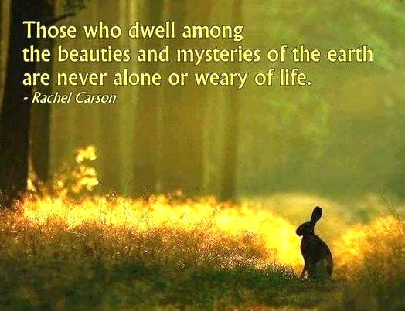
Moments of Silence
Liturgist: When you send forth your spirit, they are created; and you renew the face of the ground. (Ps. 104.30)
Welcome Sound (or any ethnic instrumental music sound)
While music is played, worship participants are invited place their nature elements at the center or around the worship place – as a way of making the worship place alive with God’s creation.

Opening Prayer:
Liturgist: Loving Creator, you care for the land by sending rain; you make it fertile and fruitful. What a rich harvest you provide!

People: All your creation sings for joy! When we take care of the land, sowing the seed and reaping the harvest, all your creation sings for joy.

Liturgist: When we keep streams and rivers clean, when we respect the purity of lakes and seas,

People: All your creation sings for joy.

Liturgist: When we recognize that we are one family, brothers and sisters together, with responsibility for the land and the waters,

Liturgist: All your creation sings for joy for you bless us abundantly all our days.
(Per Harling, from Gloria Deo, Prayers & Hymns for the 12th Assembly of the Conference of European Churches (CEC), 2003, Europe)

HYMN OF PRAISE, and/or dance of joy with creation
WELCOME AND GREETINGS, with backgrounder on why this worship service.

HOW ARE YOU, OUR MOTHER EARTH?
(Liturgist may ask volunteers from the people to answer this question creatively, or by voicing out the feelings of the Earth at this time of so much destruction, climate change, and other ecological troubles that Earth is having.)

COMMUNITY SHARING (or sharing from someone who has direct experience the impact of climate change, or destruction of the environment)

Suggested question:
From where you come from, what are the indications that our Earth is in danger or being destroyed? And how are you and your community affected by these?

Silent meditation on the sharing

PRAYER:
Liturgist: We ruin life by starting the fire in our woods. We replace the fresh air with smoke We poison our clean water and bath our children with waste. We killed our grandchildren by making them inherit poison and pest.
People: God, have mercy on us. Kyrie, kyrie, Eleison. Kyrie, kyrie, Eleison.
Liturgist: O God, we are ignoring the natural disaster, but nature is you. We are speechless, afraid of the laws abusing the nature. And we are scared of YOU.
People: And even the church as your body, we often keep quiet looking for a safe place. O God we are waiting for the new heaven and earth where truth and justice belong to all your creation O God, have a mercy! Kyrie, kyrie, Eleison. Kyrie, kyrie, Eleison. (Karo Batak Protestant Church (GBKP), Worship, Medan, Indonesia, 2012)
Moments of Silence

GOSPEL READING

HOMILY (on the theme),
OR SHARED REFLECTION on:
YOUR STORY IN CARING FOR THE EARTH.
If doing a Shared Reflection, the facilitator may prepare a board or paper and pentel pens to write on the answers to the guide questions. The answers can be further clarified if needed, and finally summarized.

Suggested guide:
- What is your own understanding of Earth Care?
- How do you translate this understanding to your daily life? How is Earth Care a part of your calling as a human being?
- How can you (or your group) help contribute to caring for the Earth in your own context? What do you think of these suggestions, below?
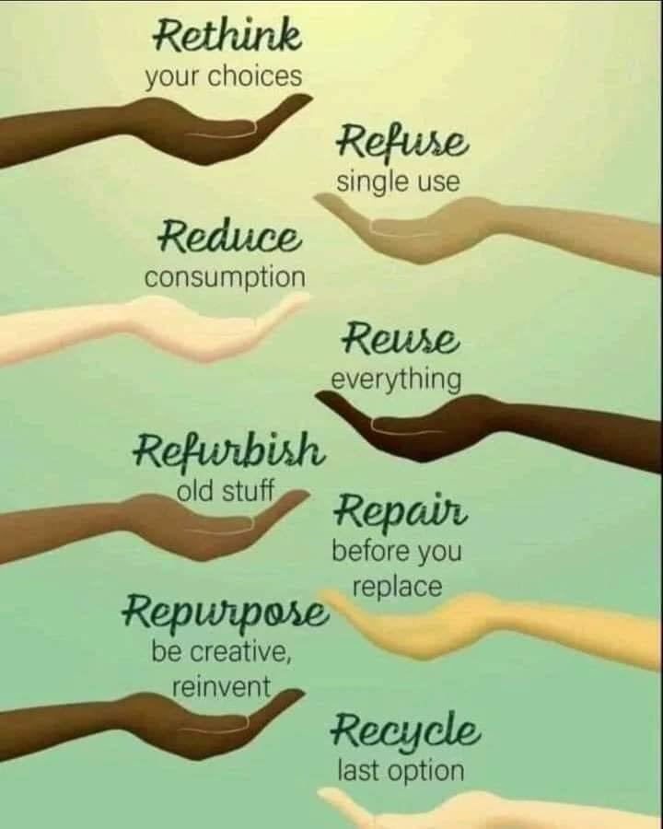
(Pachamama Alliance)
HYMN
OUR FLC STORY (Optional, see Appendix 1)
INTERCESSORY PRAYERS
Moment of Silent Prayers (People may be asked for their prayer requests or calls particularly concerning the destruction of creation, and our responsibility to care for all of God’s creation. The requests/calls can be written down in the pre-prepared leaves cut-outs, and pasted/attached onto the makeshift tree, or on the wall)
COMMUNITY PRAYER
Liturgist: God of power, God of people, God of power, God of people,
People: you are the life of all living things, the energy that fills the earth, the vitality that brings to birth,
Liturgist: the impetus toward making whole whatever is bruised or broken.
People: In you we grow to know the truth that sets all creation free. You are the song that the whole earth sings, a promise liberation brings, now and forever. Amen. (From Words and Songs of Reconciliation and Praise, Graz, Europe, 1997)

OFFERING OF FLC LEAST COIN OFFERINGS

BLESSING OF FLC OFFERINGS AND PRAYER FOR THE FLC MOVEMENT

DOXOLOGY
Praise God, from whom all blessings flow.
Praise God, all creatures high and low.
Praise God, in Jesus fully known:
Creator, Word and Spirit One. Amen.

CALL TO COMMITMENT

Liturgist: We have been guests of Jesus Christ. We have received God's good gifts.

People: Now we go to our homes, to our neighbors, to our work equipped to put Jesus' words and being into action, to be the salt of the world, to seek justice, to make peace, to preserve the creation, to gain life.
ALL: Thanks and amen. (2nd European Ecumenical Assembly, Graz, Europe, 1997)

CLOSING HYMN God’s Call for Today
(used with permission)

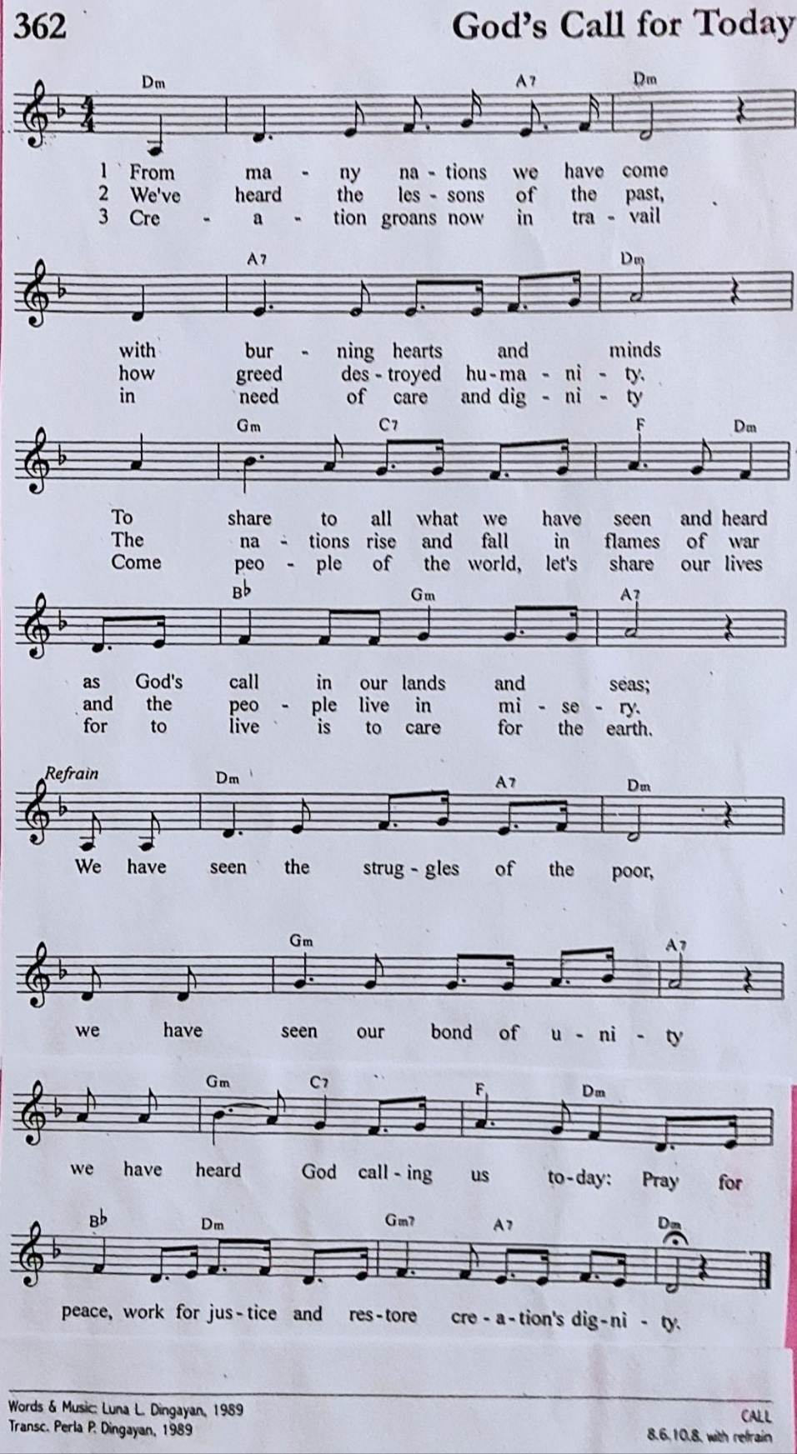

THE COMMUNITY BLESSING
Prayer:
Liturgist: Dear God,
People: We pray for another way of being: another way of knowing. Across the difficult terrain of our existence. We have attempted to build a highway and in so doing have lost our footpath.
Liturgist: God, lead us to our footpath:
People: Lead us there where in simplicity we may move at the speed of natural creatures and feel the earth's love beneath our feet.
Liturgist: Lead us there where step-by-step we may feel the movement of creation in our hearts.
People: And lead us there where side-by-side we may feel the embrace of the common soul. Nothing can be loved at speed.
Liturgist: God, lead us to the slow path to the joyous insights of the pilgrim; another way of knowing: another way of being. (Michael Leunig)
PEOPLE: May we all embrace another way of knowing; another way of being in relation to each other, and to all of God’s creation. To care for and restore this Earth – our only home right now - is our one calling. In the name of Jesus who showed us to be Christ to each other and to all of God’s creation, Amen!

BENEDICTION

THREE-FOLD AMEN

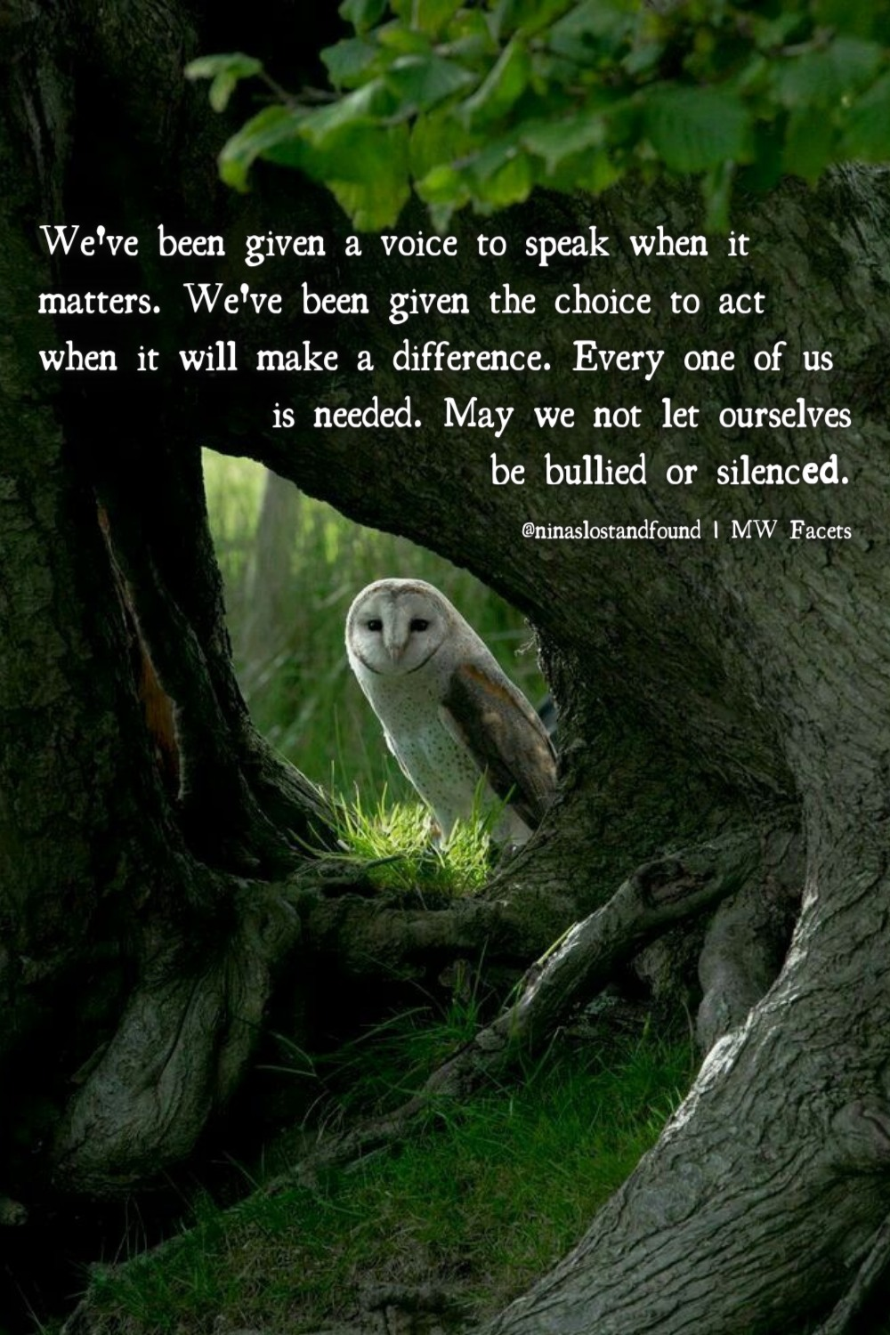

*****************************************************************

APPENDIX
Our FLC Story (Creatively read or dramatized)
Alternative 1 (Longer Version):
Leader 2: The Fellowship of the Least Coin (FLC) was envisioned by Shanti Solomon, a Christian woman from India, in 1956. Shanti was part of an international mission team led by Presbyterian women from the United States. The team travelled throughout Asia to meet with and listen to women who had been touched by injustice during the Second World War. The team heard stories of violence and trauma, deep pain and distrust.
Leader 3: When Shanti and the team went to Japan, three Japanese women met them at the airport. They brought garlands for Shanti and others on the team, but they brought none for the Americans. They said, “We have had enough of General MacArthur… we do not welcome the American women on the team.” On that visit, Shanti saw destruction all over Japan, especially in Hiroshima, where, in 1945, the United States military dropped an atomic bomb that instantly killed 80,000 people and later killed tens of thousands of people due to radiation exposure.
Leader 4: When Shanti and the team went to the Philippines, they met with Filipinas who were selling their jewelry in order to rebuild their church. It had been reduced to rubble during the Japanese occupation. When Shanti asked the women if they would receive a mission team from Japan to have conversations about reconciliation they said, “Not during our lifetime.”
Leader 5: When the team went to South Korea, Shanti stayed behind in the Philippines since her visa application was denied. At that time, India and South Korea had tense diplomatic ties. After the Korean War, Indian Prime Minister Jawaharlal Nehru accepted the United Nation’s request to be the neutral world leader to settle the boundary between North and South Korea. Prime Minister Nehru settled the boundary at the 38th parallel even though most Koreans did not want their country to be divided at all. So, as an Indian citizen, Shanti was not welcome in South Korea.
Leader 2: After hearing these stories of hurt and resentment and experiencing divisions and borders herself, Shanti prayed for peace, justice, and reconciliation between countries and peoples. She believed that if individual Christian women could pray about these issues, they could create ripples of peace, justice, and reconciliation that would flow to people and places all around the world.

Leader 3: Shanti and the team pledged to pray whenever they were in conflict with another person. They committed to praying for the person that hurt them and they committed to praying for themselves – for strength and grace to seek understanding and offer forgiveness. As well, they committed to praying for peace, justice, and reconciliation around the world.
Leader 4: As a token of each prayer, they agreed to set aside the least coin in their currency. Only the least coin was offered so that women of all socioeconomic status could be generous and participate in this peace-making.
Leader 5: Today, the FLC is a global ecumenical movement of prayer for peace, justice, and reconciliation with prayers and least coins flowing to projects that support gender equality and human dignity.

Alternative 2 (Shorter Version):
Leader 2: The Fellowship of the Least Coin (FLC) is a global ecumenical prayer movement for peace, justice, and reconciliation. Through this movement, women around the world strive to be in solidarity with each other and are reminded to pray and work for peace.

Leader 3: The idea for the FLC emerged as a vision from God to Shanti Solomon of India. Shanti was part of the Pacific Mission Team, a group of seven women from different countries that traveled throughout Asia in 1956. The mission was organized by Dr. Margaret Shannon on behalf of the women of the Presbyterian Church of the United States of America (PCUSA). On this mission, Shanti heard stories from Asian women who had experienced abuse and trauma during the Second World War. Due to unfavourable diplomatic relations between India and South Korea at the time, Shanti was refused a visa to South Korea. So, she stayed in the Philippines and prayed about her experiences and the stories she had heard.

Leader 4: When the team met her in the Philippines, Shanti shared her vision of Christian women praying for peace to transcend every national boundary and human-made division. Shanti wanted all Christian women to pray for peace, justice, and reconciliation in their own lives and throughout the world and to set aside a coin as a token for each prayer. She proposed that all women give the “least coin” of their currency so that women of all socioeconomic status could be given opportunities to be generous and participate in this peacemaking.

Leader 5: She challenged the Christian women of Asia and the women from PCUSA to combine their efforts and resources to launch this project of justice, peace, and reconciliation. The team accepted Shanti’s challenge and the FLC was born.

