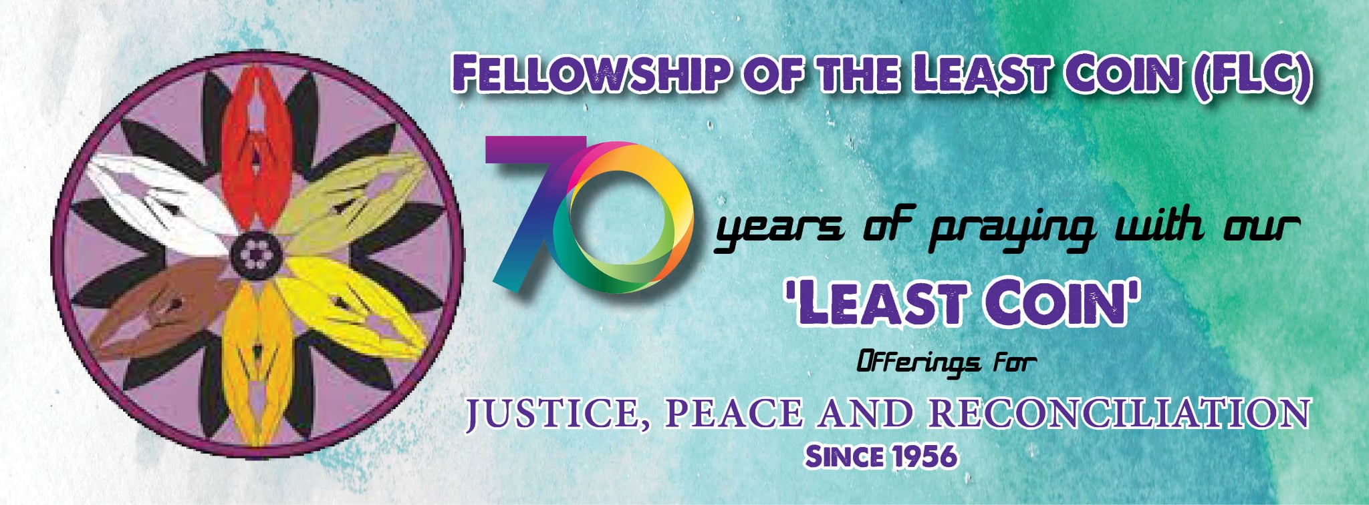

2026 FLC IN-GATHERING LITURGY

The Fellowship of the Least Coin’s In-Gathering Service is an offering from the International Committee for the Fellowship of the Least Coin (ICFLC) as a suggested guide. There is space for local women’s groups and churches to choose hymns and different ways of connecting (e.g. dramatization, message, presentation, small group discussions, etc.). Also, this service includes room for different leaders and voices to encourage wider participation, and for creativity.

The In-Gathering Liturgy is published and distributed every July of the year, just in time for the traditional month of holding the FLC In-Gathering Worship in every September of the year. And, for our regional ecumenical partners, denominational partners, women’s groups, and local congregations to hold In-Gathering Services throughout the year to suit the needs of different groups.

This year 2026 begins our 70th celebration of the FLC. Seventy years of praying with our ‘least coin’ Offerings for Justice, Peace and Reconciliation.
At a time of worsening ecological crisis, wars and conflicts and femicide, issues that we want to address and bear in mind as we commemorate the birth of the FLC, we still are challenged to “intentionally listen and hear the cries of those suffering, especially those who are deliberately muted, and those who cannot speak for themselves like our natural world and the animals.” We re-commit to faithfully pray with each other, and to set aside our least coin offerings to go with our prayers for Justice, Peace and Reconciliation.

The ICFLC would greatly appreciate your feedback on the In-Gathering Liturgy as well as personal anecdotes, stories, and photos of your worship service. Please send feedback and sharing to: icflcph@gmail.com

We pray for an inspiring, meaningful, and edifying worship experience for you, dear FLC partners, friends and fellows. Be as creative as you can and enjoy the celebrations!

FELLOWSHIP OF THE LEAST COIN @70

70 years of praying with our ‘least coin’ Offerings

for JUSTICE, PEACE AND RECONCILIATION

TODAY, we continue celebrating the 70th year of the FLC. Seventy years of praying with our ‘least coin’ offerings for Justice, Peace and Reconciliation! And there are many reasons to celebrate. You are on them!

Come around the circle and let us praise and give thanks to God for 70 years of faithful and accompaniment and blessings, and to commit to remain steadfast in the next 70 years –
to endlessly pray, to generously give/set aside our least coin offerings, and to graciously receive God’s surprising blessings through the FLC!

CHORUS OF PRAISE AND THANKSGIVING Halle, Hallelujah (Caribbean)

(Alternative: A Song to Celebrate the FLC, see appendix)

CELEBRATION SHOUT-OUTS
(Liturgist may invite people to briefly take time to think/remember and say it loud as moved to do so, from each group of people.)

For Women below 50: What do you celebrate/thankful about the FLC today?
For women above 50: What do you believe is the gift of the FLC to the world?

For young people (below 35 y/o): What is your challenge/dream for the FLC in the next 70 years?

For all men and boys: What immediately comes to your mind/heart, when you hear/talk about the FLC?

WHY WE PRAY FOR JUSTICE, PEACE AND RECONCILIATION, And with it we offer our ‘least coin’ offerings?
(an alternative is to read/dramatize the FLC Herstory, see appendix)

READING:
The idea for the FLC emerged as a vision from God to Shanti Solomon of India. Shanti was part of the Pacific Mission Team, a group of seven women from different countries that traveled throughout Asia in 1956. The mission was organized by Dr. Margaret Shannon on behalf of the women of the Presbyterian Church of the United States of America (PCUSA). On this mission, Shanti heard stories from Asian women who had experienced abuse and trauma during the Second World War. Due to unfavourable diplomatic relations between India and South Korea at the time, Shanti was refused a visa to South Korea. So, she stayed in the Philippines and prayed about her experiences and the stories she had heard.

The FLC was born in 1956, 12 years after WW 2. Today we hear of wars taking place in many places where many women, children and elderly die every day in camps.

(Liturgist may ask participants to be in a circle, to share a one-liner prayer of thanksgiving and prayer request/concern, said alternately.)

People’s Response after a thanksgiving prayer: PRAISE AND THANKS BE TO GOD FOR ALL THE BLESSINGS!

People’s Response after a prayer request/concern: YOU DIVINE WILL BE DONE, O LOVING GOD!

Liturgist: (to end the prayers) We greatly thank you, O generous, gracious God, for all the blessings. And may you see us and hear us in our prayers! In the name of Jesus our Friend and Savior, Amen!

MOMENTS OF SILENCE

PRAYER FOR THE WORLD
(Somebody could be asked to pray for all concerns mentioned, or this prayer may be used.)
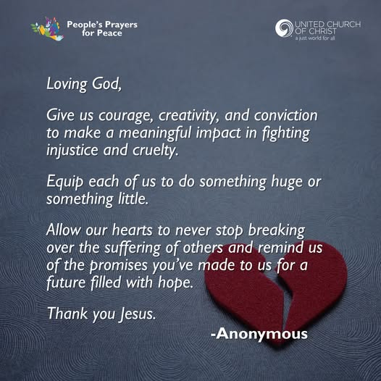

TESTIMONIES
(An alternative would be a Homily/Message for this service, on the theme)

- The Power of Prayer, from Eva Findlay, former ICFLC Treasurer (https://www.youtube.com/watch?v=a2HO0E9KS-Y)
- From Nancy Lin, former ICFLC Chairperson (see appendix)
- Or from an FLC project, scholarships or Emergency grants partner, on how has the FLC impacted her life and her community (to be invited ahead)
(Afterwards, time can be devoted to sharing of thoughts and feelings on what was heard)

(THE FLC PRAYER (unison)

Loving Creator,
We come into your presence with deep gratitude for the longing and discontent that we feel. Thank you for giving us ears to hear cries for justice, hearts to feel with those who are oppressed, and hands and feet to do something about it.
Be with us on this journey to justice, peace, and reconciliation. When we’re afraid, teach us how to face our prejudices. When we’re weary, remind us of the miracles of whispered prayers and least coins.
Loving Creator, help us to love like you and create anew the world you so love.
Amen.

WHAT IS YOUR PRAYER/BLESSING FOR THE FLC TODAY?
(In silence, reflect on what you pray/blessing for the FLC in the next years. You may write it on a piece of paper to be added to the FLC offerings up for dedication.)

DEDICATION AND BLESSINGS OF THE FLC OFFERINGS

DOXOLOGY
Praise God, from whom all blessings flow.
Praise God, all creatures high and low.
Praise God, in Jesus fully known:
Creator, Word and Spirit One. Amen.

PRAYING FOR THE FLC
(suggested: Just click this link: Eva Findlay Prays1 )

PRAYERS OF Thanksgiving and Intercession for the FLC

Liturgist:
As we join in our prayers, we reclaim our faith with action and are reminded of these verses from Exodus 15:20-21: ²⁰And Miriam the prophetess, the sister of Aaron, took a timbrel in her hand; and all the women went out after her with timbrels and with dances. ²¹And Miriam answered them, Sing ye to the Lord, for he hath triumphed gloriously; the horse and his rider hath he thrown into the sea.

Reader 1: O living God, we remember our foremothers. We give thanks for Hagar, cast out in the wilderness; Miriam, prophet and poet of the Exodus, leader through the wilderness; Deborah, mother and judge in Israel.

People: We give you thanks, O God.

Reader 2: We remember the woman who bathed Jesus’ feet with her tears, the Samaritan woman at the well, one of the first to spread the good news; Mary Magdalene, first apostle of the resurrection.

People: We give you thanks, O God.

Reader 3: We remember the women who recognized that to be a person of faith is to respond in action. We remember the women who faced the unknown in faith and met fear with courage.

People: We give you thanks, O God.

Reader 4: We give thanks for all those women who have dared to step forward and lead, for all those women who risked standing atone, and challenged the stereotypes of society.
We give thanks for … (call to mind and you may mention them out loud, the names of women in your own countries and communities.)

People: We give you thanks, O God.

Reader 5: We remember women in history who struggled for reform, who sought in their time to Minister to the needs of the disadvantaged and alienated. We remember also those women whose faces and names are unknown, yet whose works help to fulfil your vision of Shalom on earth.

People: We give you thanks, O God.

ALL: O holy and sustaining God. Make us worth to inherit their valor and vision. Challenge us again as your daughters and sons. Bring us nearer to a new vision of love, through the grace of the Holy Spirit. AMEN. (paraphrased, Pilgrim Prayer, 260)

HYMN OF COMMITMENT

God, We See What You Have Given
NETTLETON 8.7.8.7 D ("Come, Thou Fount of Every Blessing")

God, we see what you have given;
Signs of grace are everywhere!
All around are gifts from heaven —
Gifts enough for all to share.
We are stewards of your bounty,
Called to give as we've received;
And your blessings have been plenty
From the day we first believed.

We are stewards of the richness
That you send from heav'n above.
For in Christ, you gave up greatness,
Humbly showing us your love.
In a manger — gift from heaven!
On a cross — with love and pain!
You proclaimed we are forgiven;
Now you send us in your name.

Biblical References: Psalms 148, 22, 100, 150; Luke 1:46-55
Tune: John Wyeth's Repository of Sacred Music, 1813 ("Come, Thou Fount of Every Blessing") (MIDI)
Text: Copyright © 2010 by Carolyn Winfrey Gillette. All rights reserved.
Email: carolynshymns@gmail.com
New Hymns: www.carolynshymns.com/

COMMUNITY PRAYER

God, We See What You Have Given
NETTLETON 8.7.8.7 D ("Come, Thou Fount of Every Blessing")
We are stewards of your welcome
That you showed through Christ the Son.
In his living and his teaching,
Jesus welcomed everyone.
To the outcast and the stranger,
He showed hospitality!
By your Spirit, may we also
Give the welcome we've received.

We are stewards, sent out sharing,
Offering you our very best.
Through our serving and our caring
May we give as we've been blessed.
God of love, may faithful living
Be much more than Sunday talk.
Send us loving, serving, giving;
Help us daily walk your walk!

Biblical References: Psalms 148, 22, 100, 150; Luke 1:46-55
Tune: John Wyeth's Repository of Sacred Music, 1813 ("Come, Thou Fount of Every Blessing") (MIDI)
Text: Copyright © 2010 by Carolyn Winfrey Gillette. All rights reserved.
Email: carolynshymns@gmail.com
New Hymns: www.carolynshymns.com/

(An alternative: Susan Jackson-Dowd’s greetings and prayer for the FLC. See appendix.)

BENEDICTION

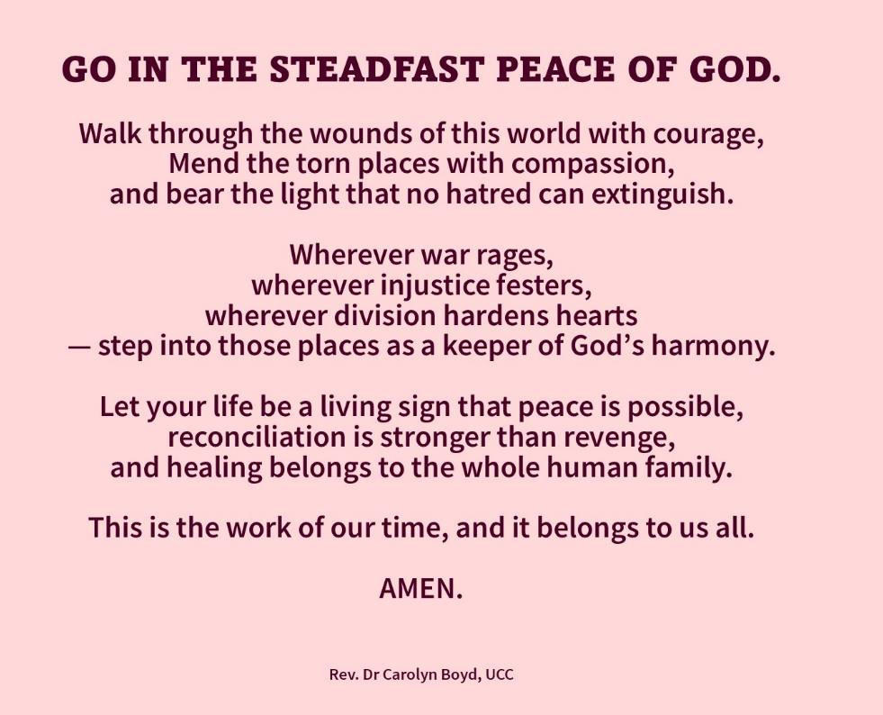

Appendices: A Song to Celebrate the FLC
From Nancy Lin, former ICFLC Chairperson
From Susan Jackson-Dowd, PW
FLC Herstory (short and long versions)

